**LCD**

**Circuit Diagram**

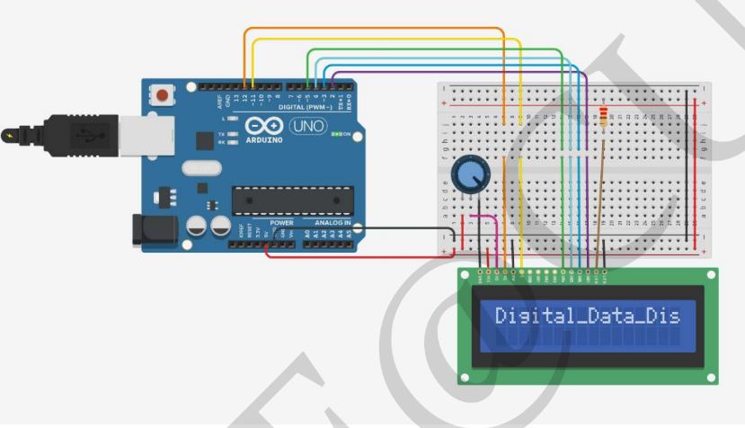

**Theory**

**Concepts Used**

1. Interfacing the push button with the Arduino and led’s.
2. Blinking of Led’s concept used.
3. Concept of Condition Statement used.
4. Concept of serial.begin used
5. Library include <LiquidCrystal>

**Observations**

In this experiment we learnt the following:

1. Basic circuit building with Arduino uno.
2. Interfacing an LED with Arduino uno.
3. Interfacing a switch with led and Arduino.
4. Interfacing a LCD with led, switch and aurdino.
5. We learn how data is displayed on the LCD.

We observe the following things:

1. We observe that how data is displayed on the LCD.
2. By changing into the code we can display anything on the display that we want to display.

**Precautions**

1. Don’t make the connection loose.
2. Before uploading the code into the Arduino make sure that the circuit is correct to avoid the damage of the circuit
3. Check the led’s are working or not with the help of the multimeter.
4. The LED should not be connected in reversed direction because it doesn’t allow passing the current and circuit does not completed and LED will not glow.
5. The LCD connection show be tight.
6. Always ensure that the LCD is working properly.

**Learning Outcomes**

1. **We learn that how data is display on the LCD.**
2. **We also learn that how to use switch with and LCD.**
3. **We also get to know the function of the “serial.begin”.**
4. **We also come to know that there is sa library file <LiquidCrystal.h> which helps to display the data.**
5. **Learn the basic concept of the LCD and working.**